Zoho Commerce Documentation

This documentation is intended to help with implementing new customers in Zoho Commerce.

Prepared by:
Adlin

Table of Content

Zoho creator application.
Using this application, we can connect to Flourish Inventory, retrieve all products, and create those products in Zoho Commerce. The application details will be included in the document.
1. How to Implement the Product Sync Logic
Step 1: Create Custom Fields
In the Item module, create the following custom fields:
- Commerce Item ID
- UMO Check (has required)
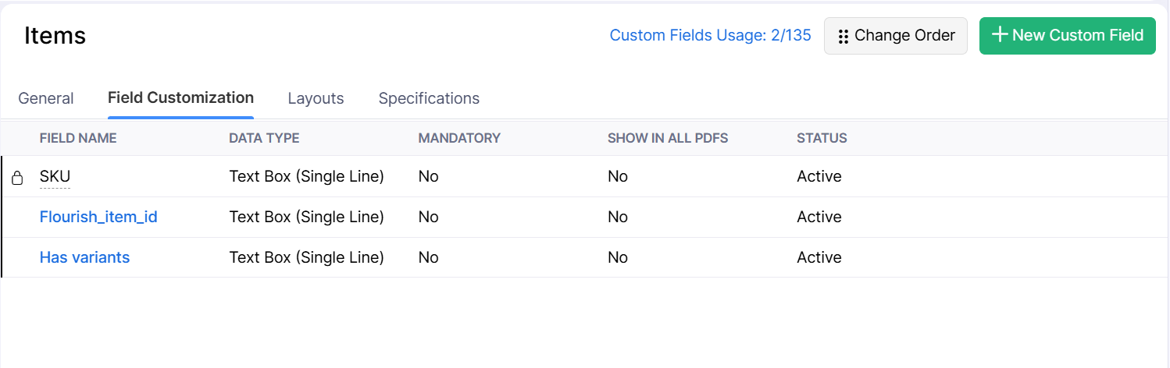

Step 2: Create a Connection in Zoho Commerce
Create a connection in Zoho Commerce within Zoho Creator.
Note:
If you change the connection name, make sure to update it in the Product Sync Workflow. Otherwise, you can use the existing workflow without change in Connection Name.
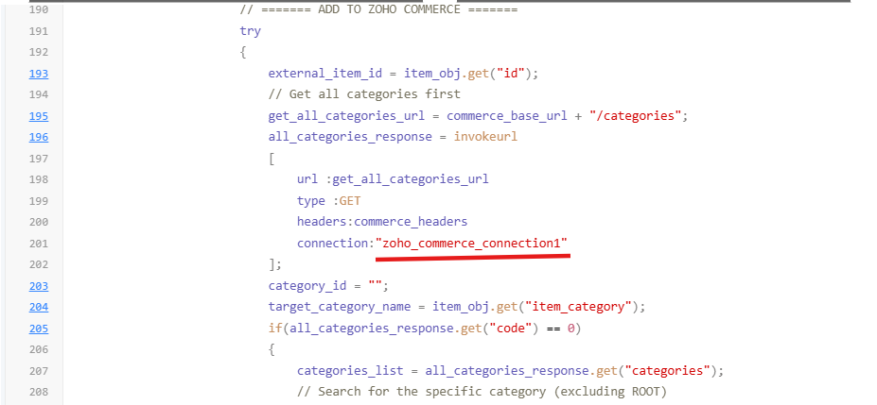

Step 3: Update Zoho Commerce Org ID
Update the Zoho Commerce Organization ID in the Product Sync code.
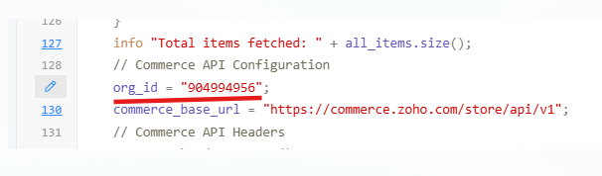

Step 4: Update Custom Field IDs
Update the custom field IDs in the Product Sync code.
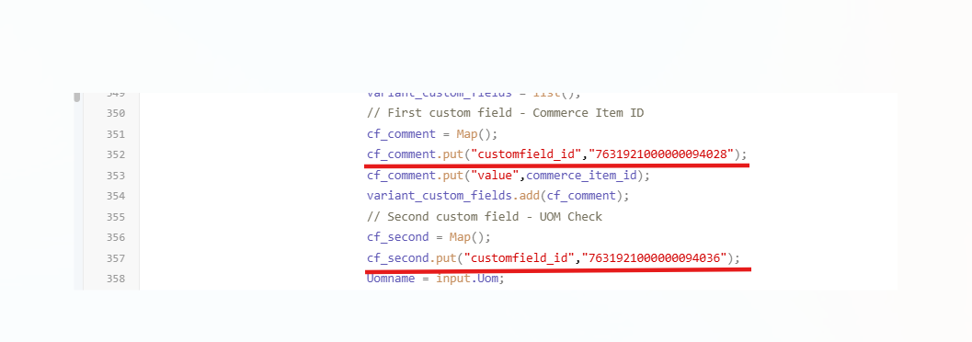

Step 5: Configure Zoho Creator API
- Go to the Zoho Creator API Configuration Form.
- Fill in the required details:
  - Auth Header
  - API URL
- Add an Initial Sync to ensure that products from Flourish are added to the Zoho Commerce Item Module.
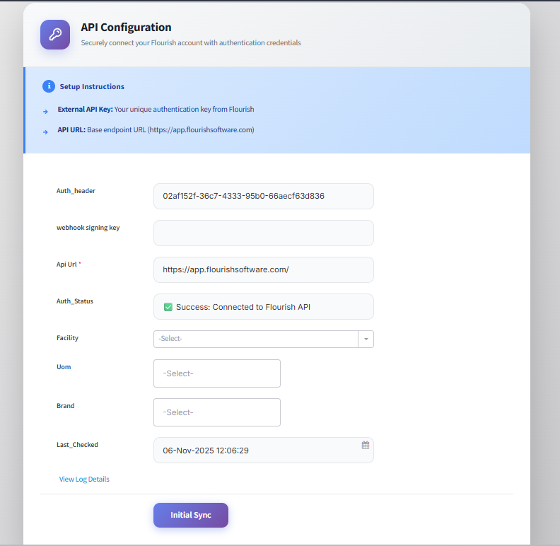

2.Register users are only allowed to access the Commerce account.
Step 1:
Contact the Zoho team and ask them to enable the Mandatory Sign-In feature.
This feature is available under the Customer Portal.
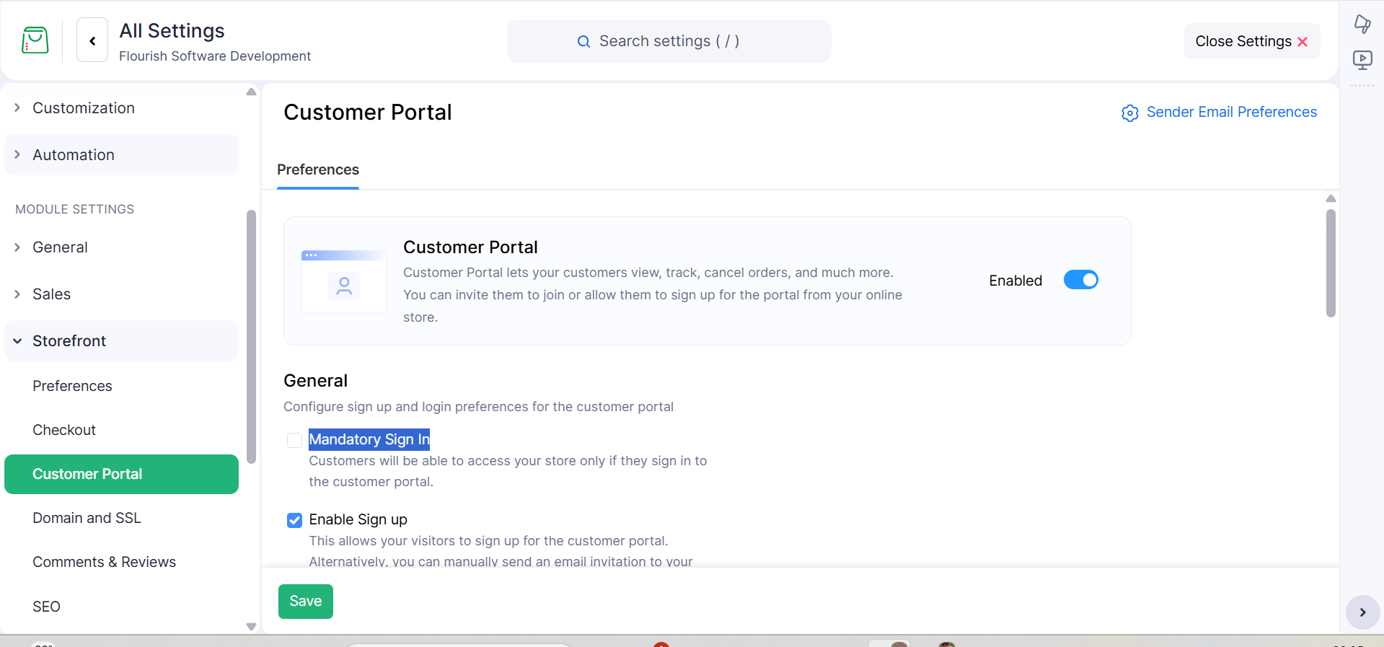
Step 2:
Create a custom module and add the required fields in the custom module.
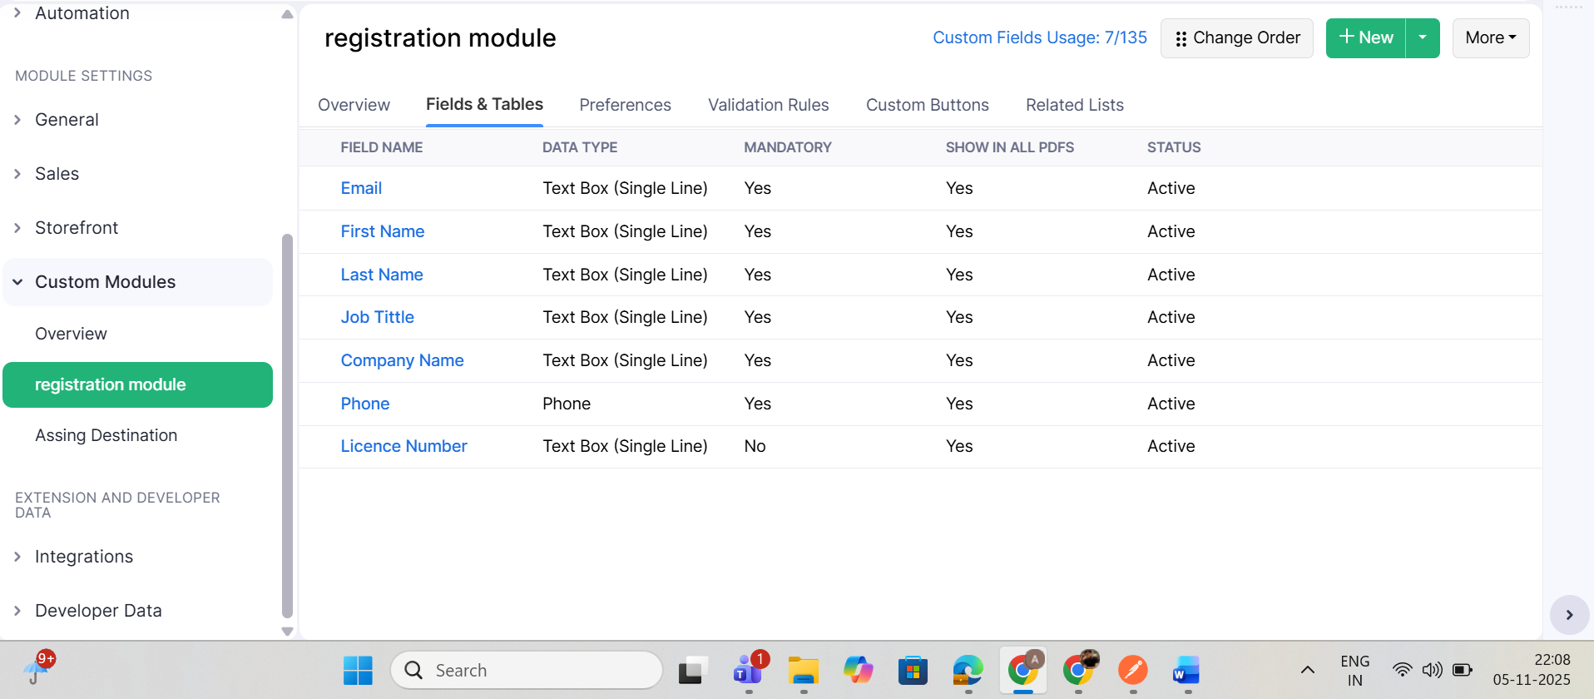

Step 3:
Create a custom button and write the logic so that when the admin clicks the button, a record is created in the Zoho Commerce Customer module, and an invitation email is sent to the user. Using the invitation email, the user will be able to create an account and log in to the store.
Step 4:
Create a web form in Zoho Commerce using the fields from your custom module.
Step 5:
Create a “Create Account” button on the user login page, and use JavaScript to link the button to your web form URL so that it redirects users to the web form when clicked.

3.How to Implement the Destination Logic
Step 1:
Create two custom fields in the Sales Order module:
- Destination ID
- Destination Name
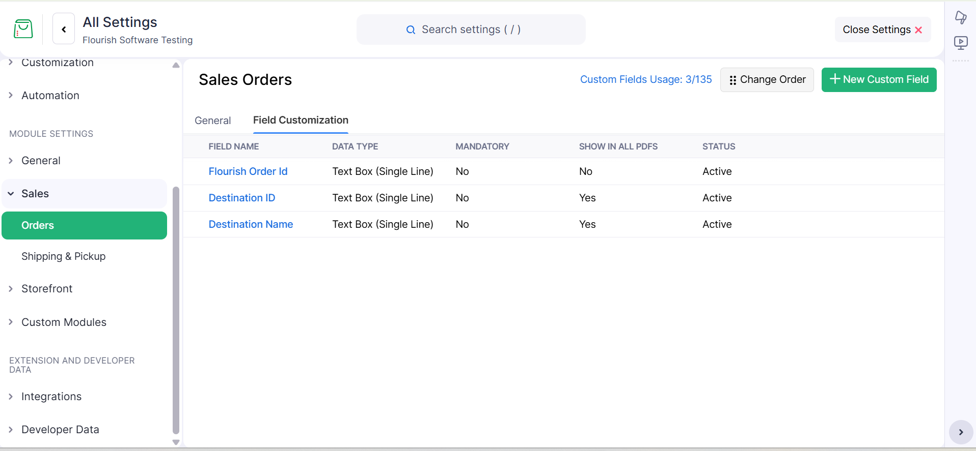
Step 2:
In the storefront, display these fields in the “Edit Address” section of the checkout page using the checkout layout option.
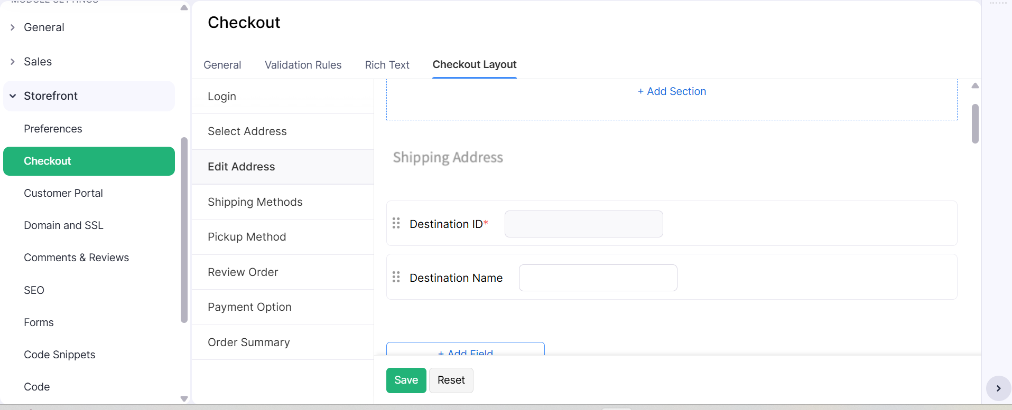
Step 3:
Create a folder named “destination” in the storefront file section. Inside this folder, create a JSON file.
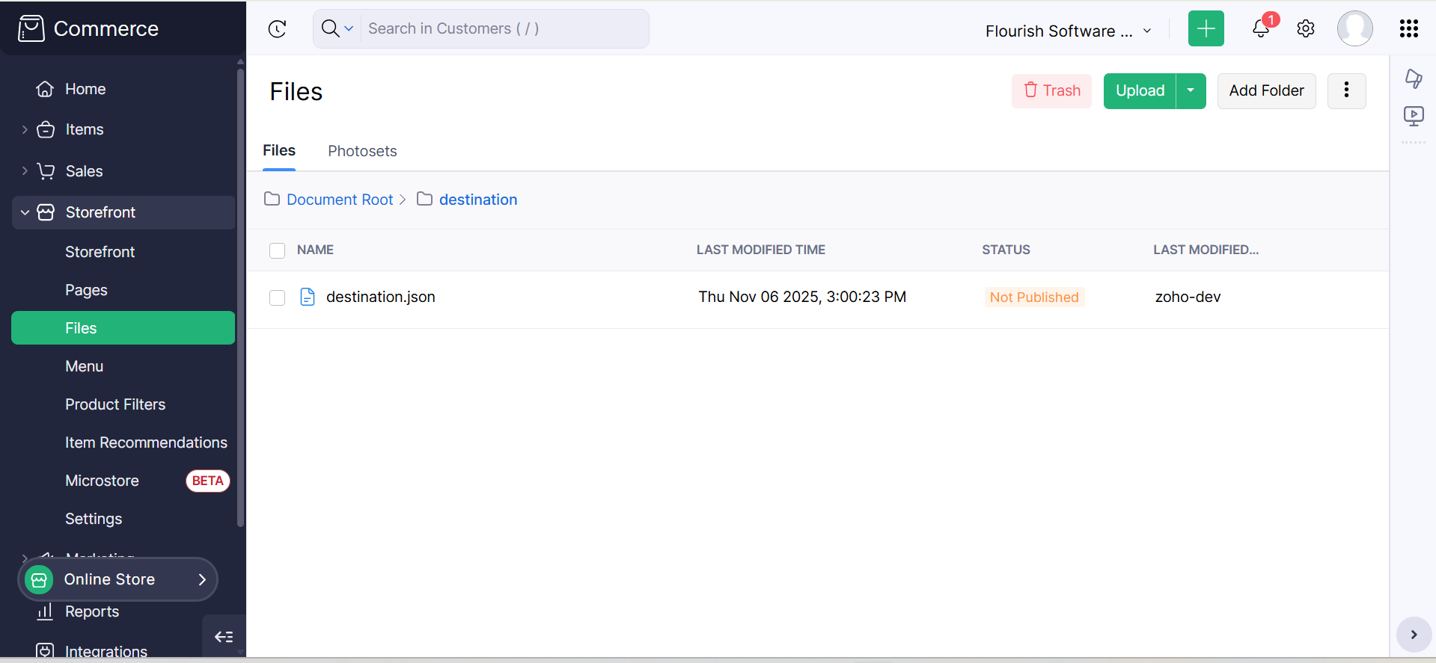

Step 4:
Write a Deluge function in the scheduled workflow section that runs every hour.
This function should:
- Retrieve all destination details from Flourish.
- Write the response data into the JSON file created in the destination folder.
- Before writing new data, delete the existing JSON file and recreate it with the same name.
Step 5:
Create a dropdown field inside the checkout address section using JavaScript code.
In this dropdown:
- Display the DBA Name and License Number for each destination.
- When a user selects a destination, automatically fill in the related fields based on the Destination ID.
- Keep the Destination ID field hidden from the user.
